**e**

**Breathwork for improving mental health in schools**

School Breathe has been delivering successful breathwork programmes to schools, both online and in person, with some outstanding results. Simply learning to adopt healthy breathing habits and engaging in a short breathwork practice (no more than 5 minutes a day) has proven to help children (and staff), feel calmer, sharpen focus and concentration, build cognitive abilities, improve behaviour, boost mood, and create healthier relationships and so much more.

With the exponential rise in anxiety and stress within educational settings, there is a real need to implement practical and effective solutions where positive outcomes can quickly be achieved.

Numerous studies have shown that breathwork is the most effective way to reduce stress and anxiety. Aimee’s presentation combines informative theory with scientific research studies regarding the effectiveness of breath practices, followed by easy to learn breathwork techniques and exercises enabling pupils and staff to experience feelings of calm and relaxation.

**Workshops**

We offer a selection of workshops, either in person or on Zoom/Microsoft Teams, including:

1. **Breathwork for a calmer classroom (for teachers) 1 hour**

In this workshop, a School Breathe breath coach will teach key breathing practices for you to share within your class. Using breathwork can have an immediate effect on how a child processes emotions, influences a calmer state of mind and can build resilience. You will also:

* Understand your unique breath pattern
* A group of people sitting in a room

  Description automatically generated with medium confidenceLearn the benefits of breathing well
* Be introduced to dysfunctional breath patterns in children and adults
* Learn the science behind breathwork
* Practise and learn to teach invaluable breath techniques to help promote feelings of calm
* Practise and teach scientifically proven techniques to help improve focus and concentration
* Learn breathwork exercises to help manage the stress response

1. **Breathwork for a calmer staffroom (for teachers and staff) 1 hour**

In this workshop, you will:

* Understand the benefits of breathing well
* Become aware of how your unique breath pattern affects the way you teach
* Learn the science and research behind breathwork
* How teaching can affect the way you breathe
* Learn key breath practices for you to soothe your nervous system
* Learn breath exercises to help you manage your feelings
* Practice breath techniques to feel calm, centred and focused

1. 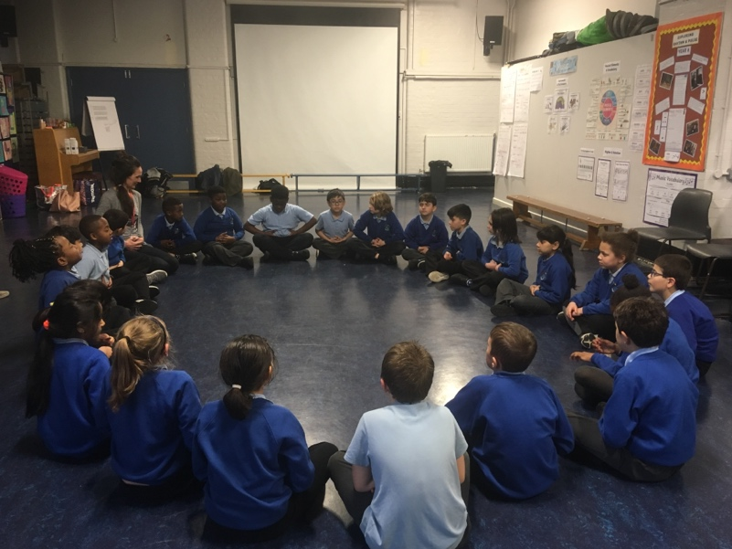**Breathwork for children 1 hour (sessions will be adapted to suit KS1/KS2):**

In this fun, interactive and engaging breath session, pupils will:

* Understand the mechanics of breathing. What is happening in the body when we breathe?
* Learn how many breaths we take per day and why it’s important to breathe well
* Learn why their breath is their superpower
* Understand how they can change the way they breathe to transform the way they feel
* Practise a variety of movement and breath exercises to help them feel calm, centred and focused
* Practise breath techniques and relaxation techniques to help them manage stress and anxiety
* Nature and breathing: Learn how insects, animals and plants breathe and how we can be inspired by the different ways the world breathes
* Take home printouts of 5 breath exercises to practise for better sleep, enhanced mood and self-regulation

We are keen to work closely with teachers and staff prior to the workshop so that we can tailor-make a breathwork session for your class or school. We can teach a variety of breathwork techniques to help you achieve specific results you desire. For instance, we can share techniques to promote feelings of calm, especially if there is high anxiety in the class. Or should the class be particularly distracted, we can create a workshop purely around focus and concentration.

**Fees**

*Breathwork sessions for 1 hour are £185 + travel. For half a day (to include a combination of breathwork sessions for both staff + children) the fee is £495 + travel.*

**School Breathe Study Results**

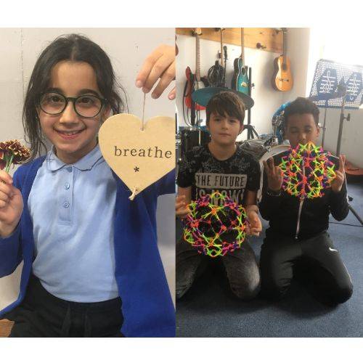

**A growing number of studies show that breathing techniques are effective against anxiety and insomnia and specific techniques influence both physiological factors (by stimulating the parasympathetic nervous system) and psychological factors (by diverting attention from thoughts).**

Children and staff on the School Breathe programme report that they use breath techniques to both co-regulate and self-regulate. Here are some of the quotes from the children:

*“We have been using School Breathe techniques after lunch at least 1 or 2 afternoons a week during well-being time. We can then talk to individual children when they are anxious, angry or upset about the techniques they've used. As we all know the exercises, this works very well”.*

Head Teacher Bellfield School, Birmingham.

*"The breathing techniques are so relaxing and help me empty my mind and feel refreshed".*

Kean, age 9, Sebright School, London

*“Sometimes when we are doing a test and I feel like I don’t know the answer, I use breathwork to calm myself down. I then usually get the answer right”.*

Cara, 10 Years Old, St Stephen’s School

*If I'm very angry at my younger or older sibling, I can calm my mind and breath down, by breathing 3 quick breaths in and 1 powerful breath out".*

Ted, aged 7, St Stephens School

*“Just five minutes of conscious breathwork practice can significantly reduce stress”.*

Stanford University

[www.schoolbreathe.org](http://www.schoolbreathe.org)

Please email: [hello@schoolbreathe.org](mailto:hello@schoolbreathe.org) to enquire or book a session.

Aimee Hartley: [www.schoolbreathe.org](http://www.schoolbreathe.org)

Instagram: @schoolbreathe

Twitter: @schoolbreathe

Mobile: 07826 205 163

Landline: 01600 719 278

**www.schoolbreathe.org**